Cs3240 project

G2 2014

Samuel Yam, Kuek Kiang Kuang, Oswell Chan, Yong Jia Jie

Contents

Introducing **ProGress** 1

Primary User Persona 2

Secondary User Persona 7

Key Tasks performed by Users 9

Formative Evaluation 19

Major Findings from users 21

Team’s Contribution 23

# Introducing **ProGress**



**ProGress** is the navigational application that we seek to develop for our project. The roots of **ProGress** began when we first identified the lack of a built-in alarm system on navigational apps; a feature that is essential for those who constantly miss their stop when multi-tasking while traveling. Taking this idea, we seek to transform it into a full-fledged product that would be an improvement to the current navigational application offered.

In G1, we conducted contextual inquiry on potential target users of our product and gathered several more requirements that could help solve the current design problem. Building on that, in G2, we will be further refining the scope of our project to cater to the needs of our target users. To aid us in accomplishing this, we will be defining a few user personas to keep us focused on developing for the users.

# Primary User Persona

Based on the 4 target user groups that we have discussed in G1, we will be selecting the target groups: Tourists, Commuters who lack a sense of directions, and Commuters who are distracted while travelling to create our 3 primary user persona for our project as ProGress was designed mainly based off the concerns of these target groups during contextual inquiry.

|  |  |  |  |  |
| --- | --- | --- | --- | --- |
|  | |  | | --- | | **Saitama: Retired** | | *“These days I just spend my time travelling the world”* | | Employer: None  Background: 65 Years old, Single and available | |
| **Quick Takes on Saitama**   |  |  | | --- | --- | | **Gender** | Male | | **Occupation** | Retiree | | **Navigational Competency** | Amateur | | **Technical Competency** | Beginner/Novice | | **Background** | Photography Fluent in both Japanese and English Living off his life savings  Enjoys travelling | | **Target User Category** | Tourist | | |
| **Key Goals**  Saitama is already in his mid-60s, retired and believes that he should fully seize whatever time he has left in life to explore the world and expand his horizon. As such, his passport is already filled with stamps from many foreign customs.  Though he can afford to travel around the world, he is still pretty much limited in terms of spending by his life savings and have to resort to sticking to budget planning whenever he travels around. | **A day in the life**  Saitama goes around from places to places to take photos of different sceneries and cultures. Most of the time, *he is non-native to the place* and have to rely on his navigational skills to get around places.  Sometimes, he asks the locals to get more information regarding his destination. But often enough, either *there is a language barrier or there are no one around for him to get information*.  “I wish I can **get some comments with regards to the route I am taking to my destination**, I like to know some miscellaneous information such as sceneries that I can see while I take that route or the cost of travelling for that route.”  “I have no problem navigating around, **I just need to know if there are better routes that I can consider** to either help me save money or provide more tourist landmarks for me to visit.” |

|  |  |  |  |  |
| --- | --- | --- | --- | --- |
| https://lh3.googleusercontent.com/Metkx8cRPBl7suQbNU8WdAjLkrtiFfOpu7HVfGf_tBdjjhC3TYZ4Czf439EqVxQ0tVjNBJaIm0B59fbytW2DUE2zR45y3qDNMtDhunSKr94qF89xV4lGsTrjkWfl-w | |  | | --- | | **Holly Anders: Manager** | | *“Oh no, that was the mall I was supposed to alight at!”* | | Employer: Jurong Port Pte Ltd  Background: Bachelor of Business Administration from NUS  Jurong Junior College  Jurong Secondary School  Jurong Primary School | |
| **Quick Takes on Holly Anders**   |  |  | | --- | --- | | **Gender** | Female | | **Occupation** | Office Manager | | **Navigational Competency** | Abysmal | | **Technical Competency** | Proficient | | **Background** | Business Marketing Management  Others: Sociable | | **Target User Category** | Commuters who lack a sense of direction | | |
| **Key Goals**  Holly’s whole life had only revolved around the west area of Singapore. Her lack of opportunity to travel around the country has led to her gaining little navigational skills.  Now that she has started working and is required to travel around more often, she realizes that her lack of navigational skills is hindering her ability to travel around the country. She wishes to use technology to make up for this handicap in life. | **A day in the life**  Once a month, Holly is tasked to give a business proposal presentation at various partner company’s office located in the east. She heavily *relies on technologies such as Google Maps to plan her route to those unfamiliar every time.*  Even when she knows what buses to take, **she still has trouble identifying common landmarks to determine when to alight from the bus**. This is mainly due to her lack of exploration of the eastern parts of Singapore in her youth. |

|  |  |  |  |  |
| --- | --- | --- | --- | --- |
| https://lh5.googleusercontent.com/AI7q4FpDieiCEG9YfwD0SR-B_pBigkykpa2yo-sTIbLZHbiKhECi1Lq3HSlqLkQhcfe7oa1zRjz0Amjg7bVwXOOKoEKAFbZkcttTD5KkgqtjtBEPwVk-ALUXANhCMQ | |  | | --- | | **Ukato Chan** | | *“Time is limited enough without wasting it doing nothing.”* | | Employer: None  Background: University Undergraduate | |
| **Quick Takes on Ukato Chan**   |  |  | | --- | --- | | **Gender** | Female | | **Occupation** | Student | | **Navigational Competency** | Expert | | **Technical Competency** | Intermediate | | **Background** | Currently studying at NUS Computing  Fluent in English, Mandarin and Japanese  Interested in manga, anime, games and Japanese culture | | **Target User Category** | Commuters who are distracted while travelling | | |
| **Key Goals**  Ukato is a young adult in her early twenties. Her personality is such that she dislikes to be bored. She believes that time is precious and thus, always spend her free time indulging in her interests.  Ukato is currently still schooling and as such, does not have much money. Her main mode of transport is public transport, such as the MRT and buses. However, due to the long duration of time public transport takes to get from one destination to the other, this introduces a lot of free time. | **A day in the life**  Ukato travels to school using the MRT. As she lives in Pasir Ris, the whole trip to NUS can take almost 1.5 hours. As such, *she often plays mobile games on her smartphone to spend the time.*  Sometimes, she chooses to read a book or study on the way to school.  However, **it is quite common for Ukato to be too engrossed and end up missing her stop.** She sees this as a nuisance and a waste of time. She hopes that there is an app that can help her resolve this issue. |

# Secondary User Persona

The remaining target group which is Commuters who needs to travel to unfamiliar places often will be forming the secondary user persona, because the key goals and concerns of this target group seem to have some overlaps with the key goals of the other 3 target groups.

|  |  |  |  |  |
| --- | --- | --- | --- | --- |
| https://lh6.googleusercontent.com/mmYqk3c8tg2CZ4lfx1zRWWfaN0bGNbcSoebh0wiyRroTY2mVOGH0-EDP7Fl-VCVhu-rpbaLzcd_S6DiZy_cnhhvtX61mwZb0hPfCg8ORWwcIffb1QPsYDt2N838UeQ | |  | | --- | | **Ken Kingsly: Corporate Sales Rep** | | *“Let’s meet where it’s convenient for you”* | | Employer: Samsung Siltronics Wafer  Background: Masters from UCLA | |
| **Quick Takes on Ken**   |  |  | | --- | --- | | **Gender** | Male | | **Occupation** | Sales Representative | | **Navigational Competency** | Expert | | **Technical Competency** | Novice | | **Background** | Business Marketing Management  Others: Sociable | | **Target User Category** | Commuters who need to travel to unfamiliar locations often | | |
| **Key Goals**  Ken is one of the more senior representative representatives for the company. As such, he manages the oldest of the customer accounts that have been around as well as a flurry a new accounts which require a more “delicate” approach.  He believes in saving as much as possible, and as such, is an advocate of public transport despite being a senior member of the sales force. | **A day in the life**  Ken meets up with his old account clients on a regular basis, as much as everyday if negotiating a big sale, or as little as once a month to update them of his company’s latest offerings  Ken *hardly meets a client at the same location consecutively*. As such, even though he may be traveling to a place he has already gone to before, chances are, he does not remember most of it. Having a client to meet up with almost every other day does this to him.  “I need something that tells me **how to get where I need to be, not just show me that I can get from one place to another**.”  “Being late to an appointment is the worst thing a sales rep can do.” |

# Key Tasks performed by Users

Based on the requirement analysis for solution that was previously done in G1, the list of requirements to solve the design problem statement are as follows:

* Reminder Prompt Function
* Visual aid
* Community Input
* Up to date and reliable information
* Ability to work offline
* Real-time Update

By studying our persona closely, we realized that the key tasks that our final product, ProGress should be able to perform includes:

1. **Reminder Prompt function** for users who needs an alert to tell them when to alight at their stops

*(Ukato Chan who often misses her stops because she is doing something else rather than keeping track of her current whereabouts)*

With the reminder prompt function, users like Ukato will be able to better use her travelling time to do other things, such as studying. This is a much better use of time as compared to constantly keeping track of her current location.

The corresponding storyboard that depicts how our ProGress application is able to remind Ukato to alight at the right stop is titled, “*Journey of Ukato*”.

1. The **visual aid feature** for users who lack a sense of direction or surrounding awareness

*(Holly Anders’s navigational competency is poor, and providing a map alone does not help her since she would not understand it)*

The visual representation of landmarks or destinations can better help users like Holly and Ken to orientate themselves to the current location. This removes the frustration to constantly look at the map and do map-to-ground comparisons of the surroundings to confirm that they are on the right route.

The corresponding storyboard that depicts how our ProGress application provide visual representation of the landmarks/destination is titled, “*Journey of Holly*” and *“Journey of Ken”.*

1. **Community input** for users who prefer first-hand feedbacks and experiences of travelling a particular route

*(Saitama’s foreign origin makes him oblivious to the native’s countries sights of interests as well as the traffic/travelling conditions)*

Having information/first-hand feedback tagged to a particular route provided by the community enables users like Saitama to be well informed on information (such as cost, sights of interest) that he can take into account when he is planning his travelling routes around the country.

The corresponding storyboard that depicts how our ProGress application provide community inputs is titled, “*Journey of Saitama”.*

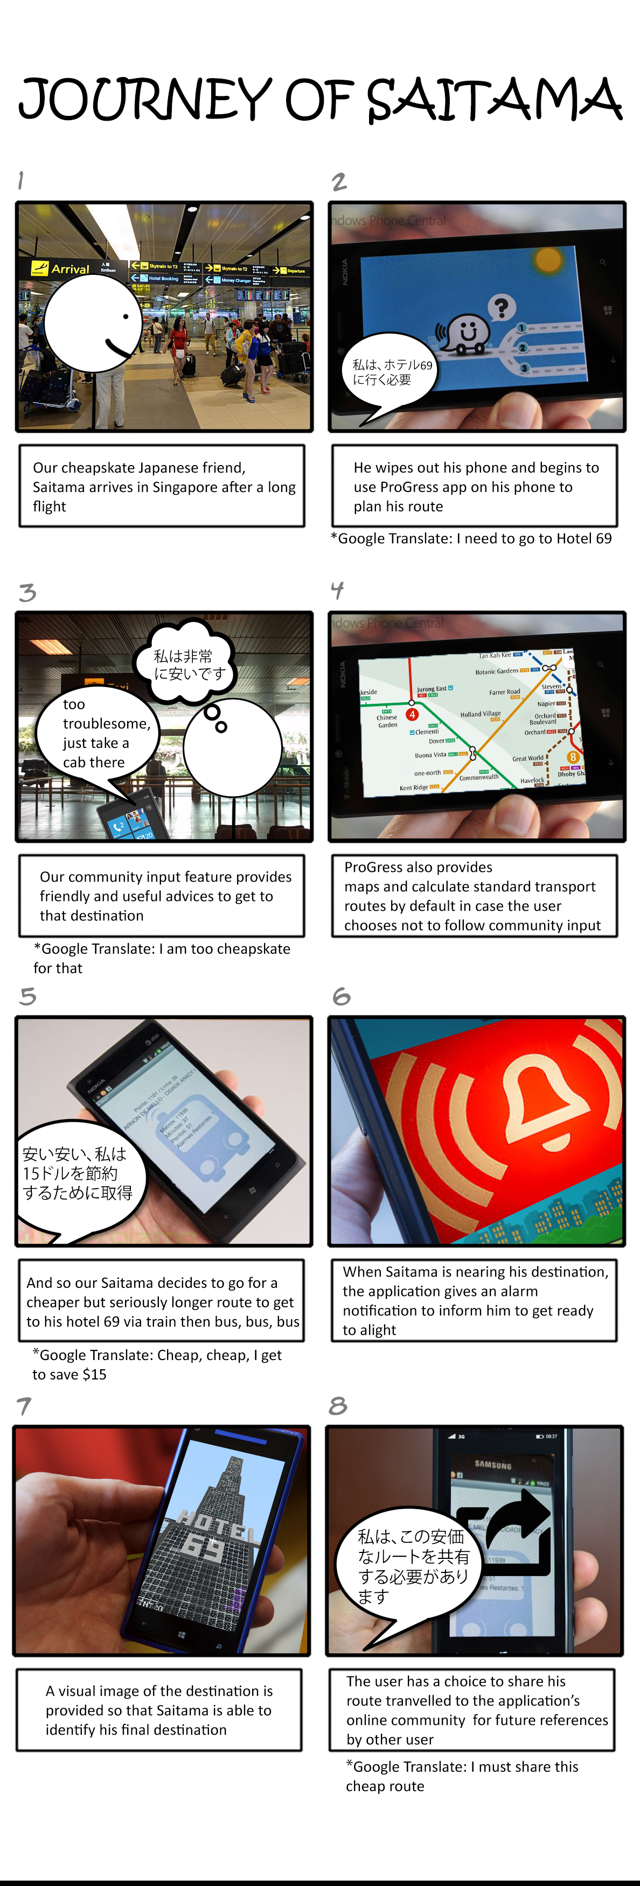





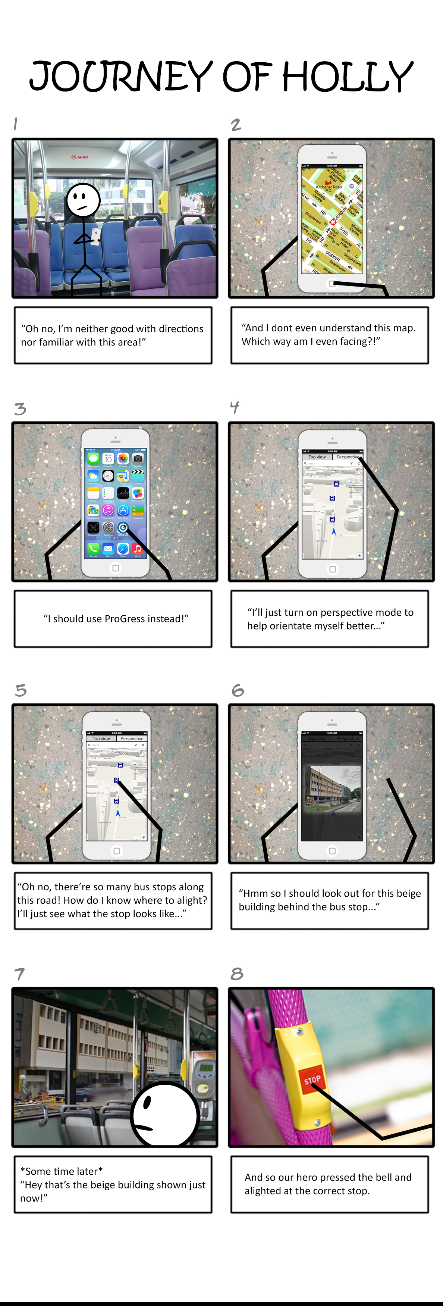



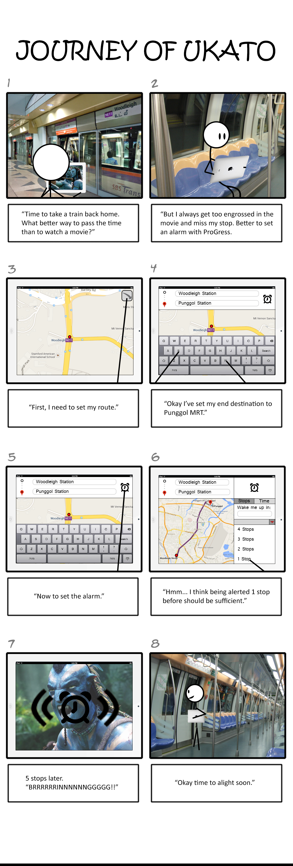



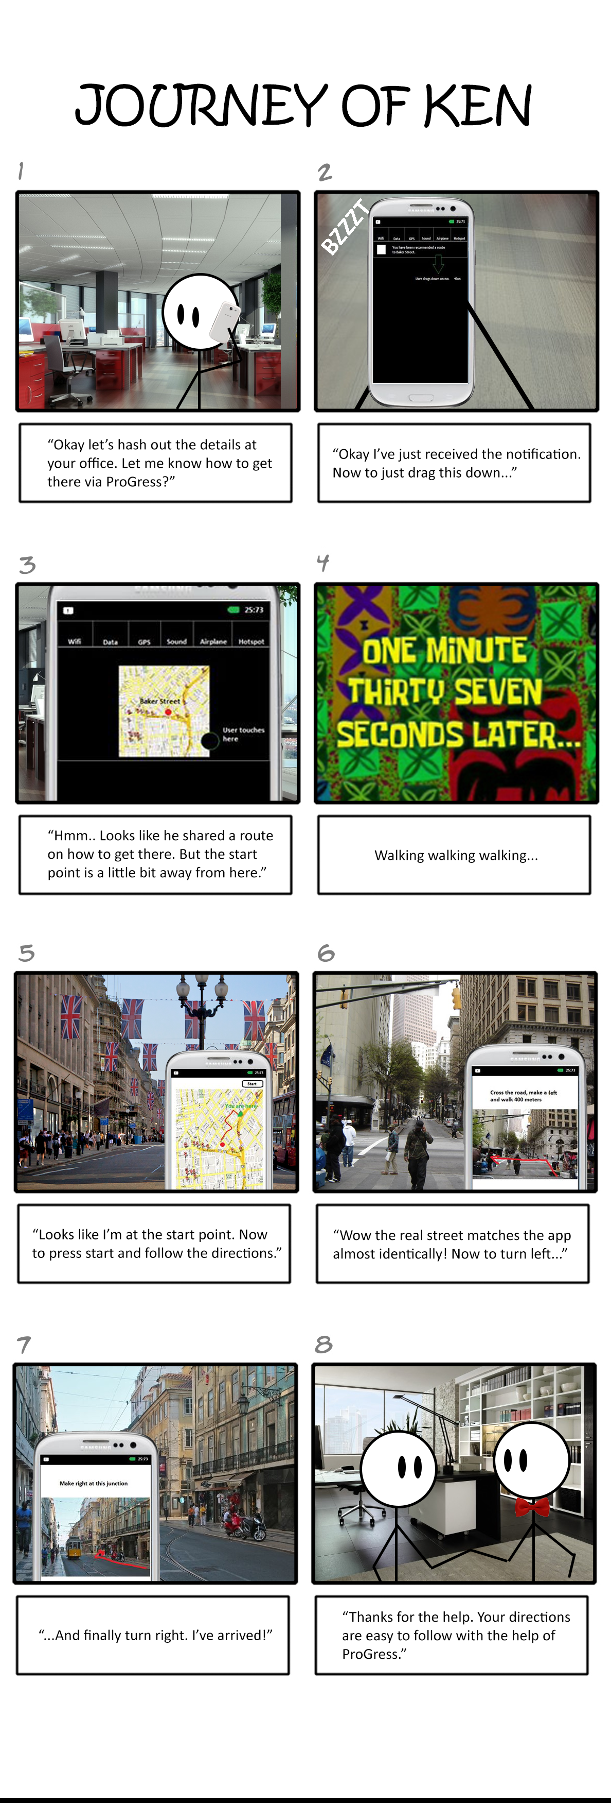





# Formative Evaluation

Evaluation Process

In conducting the evaluation of our prototypes, we found four participants to evaluate our prototypes. The usability test we used to gather data was the “Think-Aloud” protocol. Before being shown the prototypes, each participant was briefed about the purpose and key features of our product, **ProGress.**

At the start of our actual evaluation process, prototypes of our individual visions of the final product were shown to the participants. A group member was tasked with recording down the think-aloud responses and did not take part in conducting the evaluation.

Each participant then went through all four prototypes and performed the three key tasks defined *(Reminder Prompt, Visual Aid of the destination and Community Input)* while elaborating on their observations and current feelings. When they were done with each prototype, they were further asked about their overall thoughts on the individual prototype and areas for improvement.

Reflections on the Evaluation Process

During the evaluation process we realized that we often had to explain and give a walkthrough of our product, **ProGress**. This indicated that the current interface design of our prototype was not intuitive enough. The evaluation process was also limited by the medium. The paper prototype we displayed and did not reflect the actual usability of the final application. For example, the swiping of pages and the clicking of icons or buttons could not be experienced on a printed prototype.

The evaluation process provided a lot of new feedback on design that we had simply overlooked during the creation of prototype. Just from the process of explaining our prototypes to the participants revealed many obvious flaws that we previously had overlooked. (These new insights are documented in the major findings section)  
  
All of the users were very cooperative and responsive during the entire evaluation process by providing constructive criticism of our prototype. Those who were observing and recording the evaluation process were able to tell that certain users felt awkward having to enunciate their rationale for certain choices as they were proceeding through the think aloud process. As evaluators, we attempted to alleviate the awkwardness by prompting them when they felt stuck or silent. As the evaluation progressed, the awkwardness subsided for many of the users.

Overall, the experience with the “Think-Aloud” protocol has been a positive one. We were able to gain many new and valuable insights on how to improve our product. With these new insights and findings from the users, we are better equipped with the knowledge and experience to create a high fidelity and better version of our product **ProGress**.

# Major Findings from Users

**Interface design**

There is a lack of feedback in terms confirmation prompts or progress bars to indicate the status of the user’s progress

Some icons on the interface are not obvious to the user that they can click or use it

It is unclear whether the distance is set by radius around the destination or a single route/path from the destination

There should be an option to set a favorite route of the user

**Community Input**

There should be a way to control the heavy influx of community input, and moderate/validate the routes contributed by the users

The ratings from the community input for a particular route should be shown with the route without the need of the user to bring up the community input to view them

There should be votes for the route itself and for the comments of the community input (Currently only one of the two is being used throughout the prototypes)

The app should automatically filter out useful community input from useless community input (i.e via voting or moderation, Editor’s pick, Commuter’s choice) while still providing a choice to do otherwise.

**Visual Aid**

The visual aid needs to allow the users to be able to look around the surroundings of destination

Visual aid of places can be shown without a need to first set an alarm

**Reminder Prompt**

There is a lack of indication of how much time/distance you have left before reaching your destination when your alert notification rings

User does not understand the significance of the distance to them when they are setting their alarms by distance, instead they will be more reliant on setting their alarms using bus stops

User can set a reminder prompt when to alight without the need to first plan out a route

Not compatible for other modes of transport besides buses

Types of notification reminder settings is not specified (vibration, ringing)

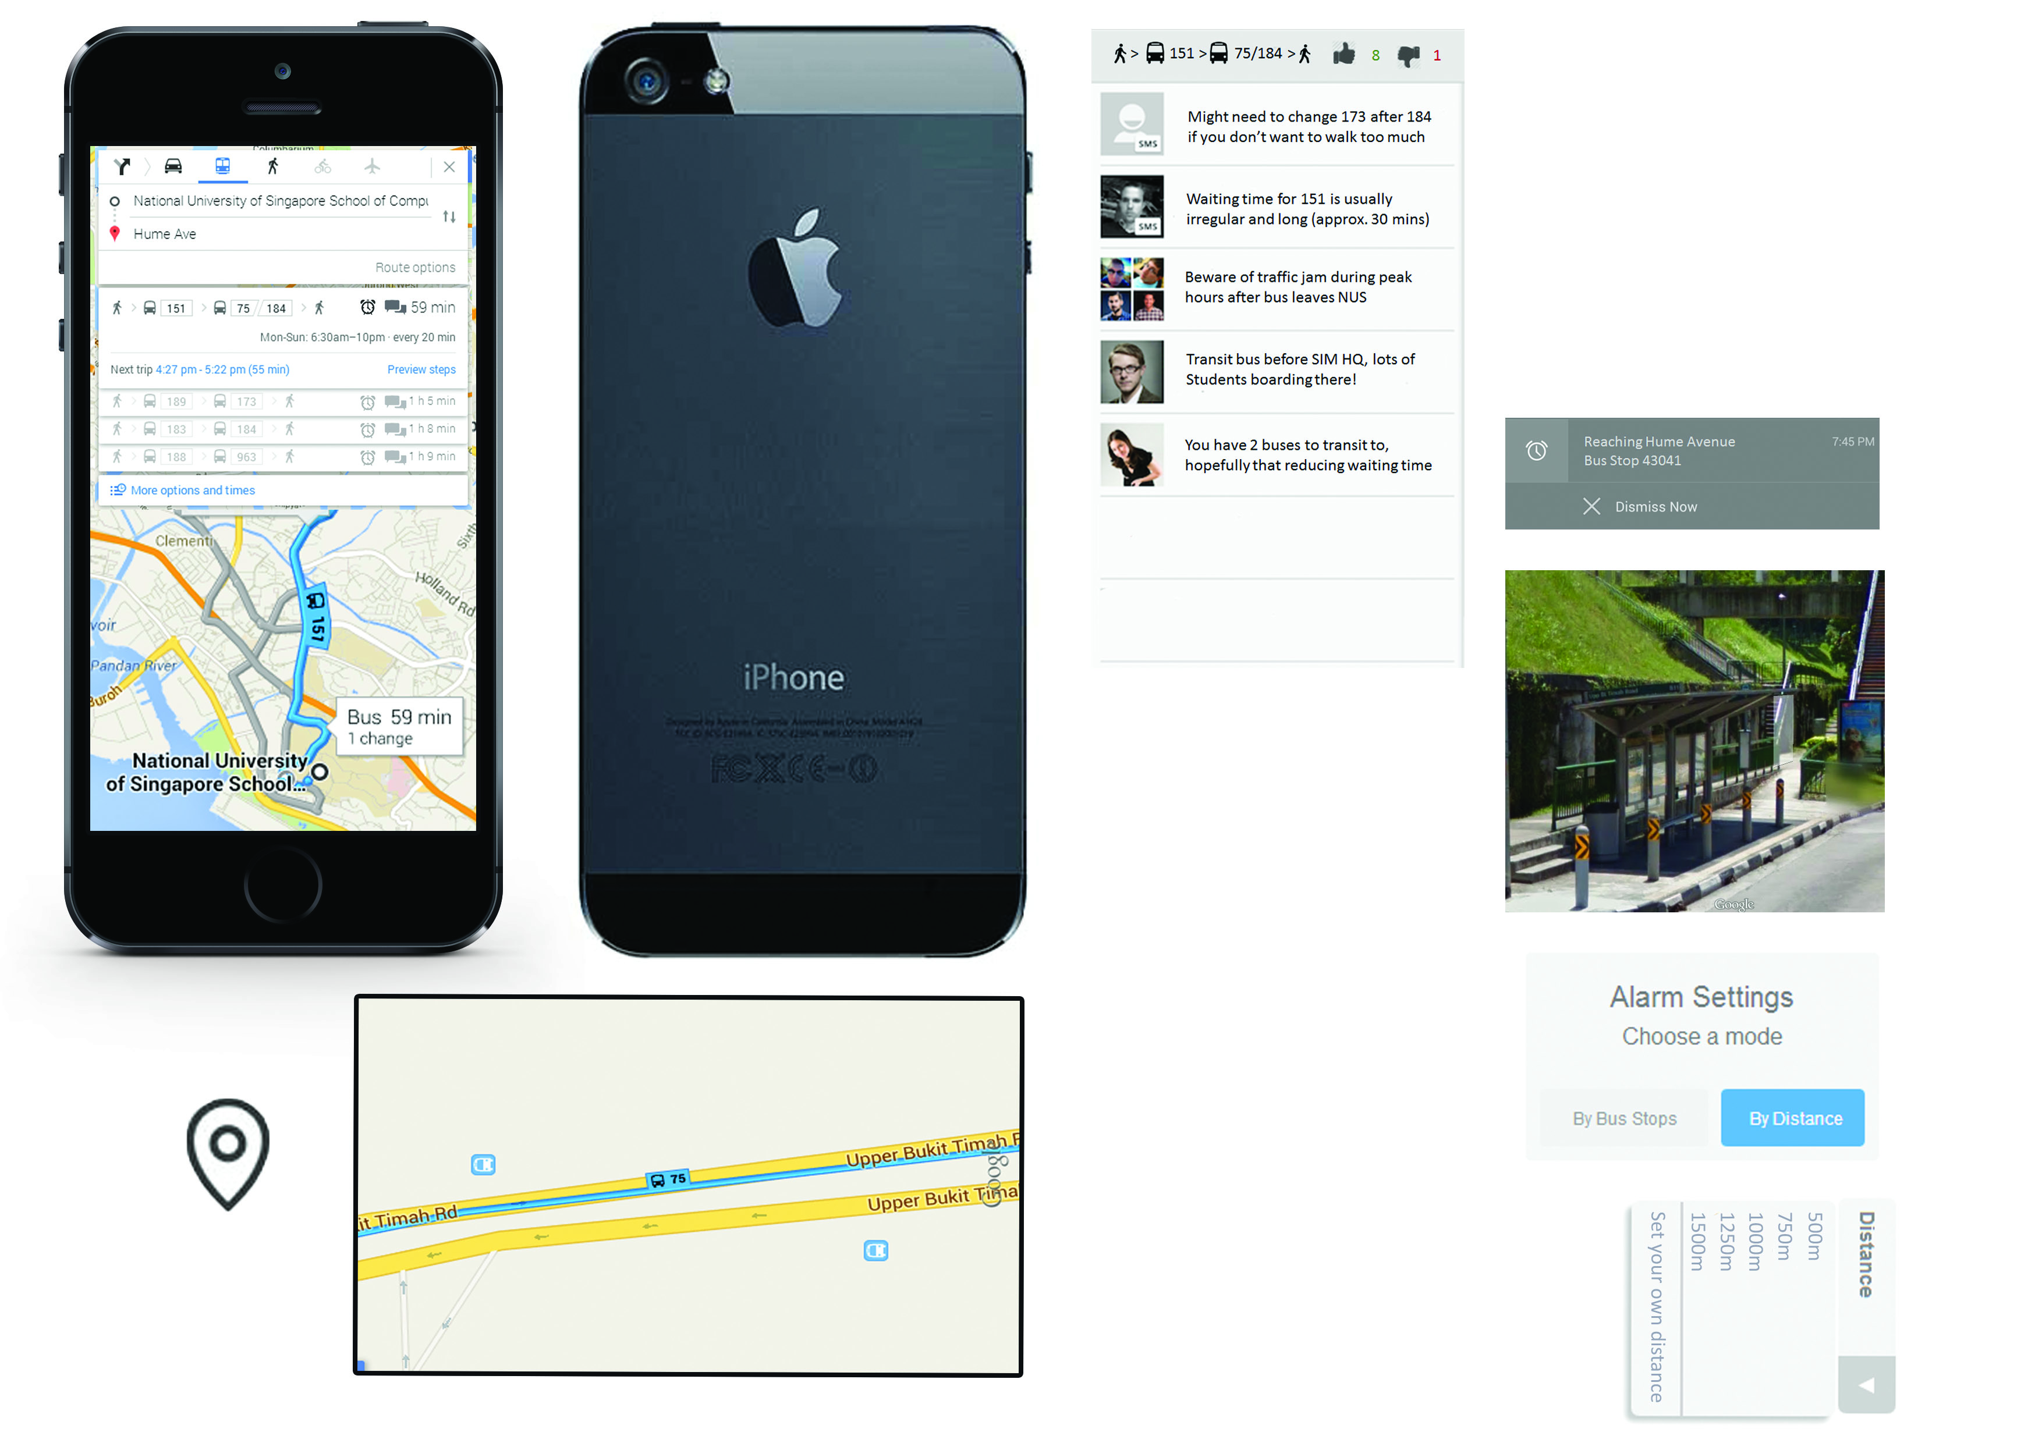

|  |  |
| --- | --- |
| Jia Jie | |
| Pros | * The interface is very similar to Google maps which users are already familiar with using * Actual use of routes and photos of destination were used to make it as real as possible |
| Cons | * Icon logos and fonts used are too small * New buttons looked like icons alone rather than buttons that can be interacted with * It is currently not made compatible for train stops * The distance set can be ambiguous to the user whether it is in terms of radial distance or distance by the route taken * Lack of confirmation/progress bar to indicate the status * May not seem intuitive to a new user * Lacks the perspective view for the map to orientate the user properly * Missing an input channel for the community input |

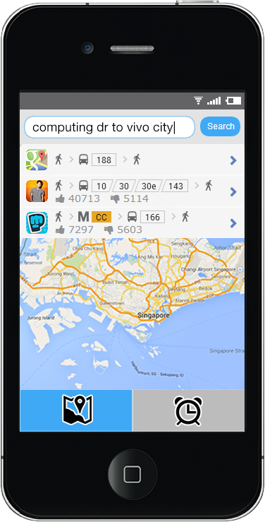

|  |  |
| --- | --- |
| Kiang Kuang | |
| Pros | * Interface is very intuitive to use * Design is very clean and simple, not overwhelmed with options |
| Cons | * Search bar not obvious that it could be used to search for directions * Should show the time taken for each route displayed on the search * When the visual aid picture is shown, the background map which could be still moving becomes distracting * Should have a confirmation button when trying to set alarm * Visual Aid should be able to move around like Street View * Could request for ratings in the form of phone notification instead because people usually close the app once they are sure they are reaching the destination * Setting of alarm by distance is impractical as people cannot gauge the distance anyway while on the vehicle |

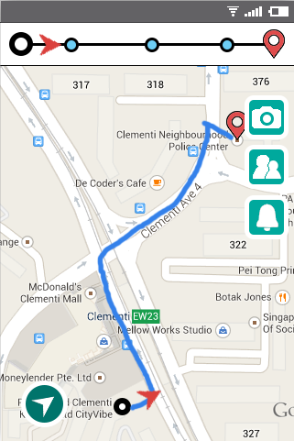

|  |  |
| --- | --- |
| Oswell | |
| Pros | * Progress Bar present (helps to keep track) * Drag and drop alarm feature was intuitive and clear |
| Cons | * Walking routes are absent * Some buttons were ambiguous (camera button and perspective button) * Lack of an estimated end time to a journey * Checkpoints on progress bar are unclear * Hard to see the checkpoints when you zoom out * Pictures are static and are not representative of each perspective * Community input is cluttered |

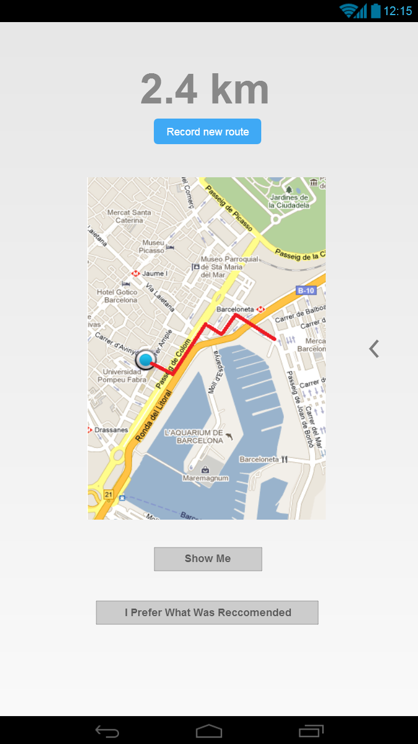

|  |  |
| --- | --- |
| Samuel | |
| Pros | * Easy to understand and use * Simple * No one only route available |
| Cons | * UI design could be more appealing * “Trolling” a possibility * Should not need select a route to preview it |

# Team’s Contribution

# Conclusion

In completing G2, our team has managed to tighten our focus on three main tasks that we wish for **ProGress** to be able to carry out. In testing out our ideas, we each made a prototype and evaluated it with prospective users using the “Think-Aloud” protocol. From this test, we were able to gain many valuable insights that we would otherwise be unable to attain. Following up on those insights, we will be taking the best parts of each of our prototypes and putting them together. Feedback received from the prototype evaluation will be the main consideration in our next subsequent design of **ProGress.** Building upon the experience gained in the designing of the prototypes and the insights gleamed from prospective users, we are certain that our end product will be a polished and useful application for our target audience.